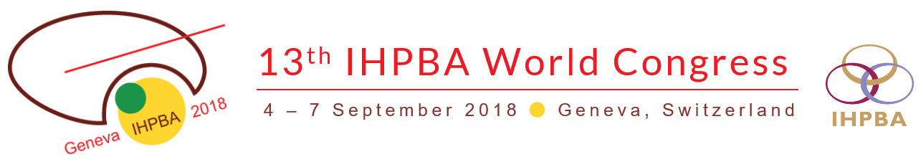

Chatzitheoklitos, Efthymios - Activities
Video Session
Pancreas
06.09.2018 08:00-09:30h | Room: Room K
VID05 Competitive Video 5 - Pancreas 2
Selection of Presentations from Video Abstract Submissions

Toar Lalisan (Indonesia)
- Efthymios Chatzitheoklitos (Greece)

VID05-01 | First Robotic Pylorus Preserving Pancreaticoduodenectomy for Solid Pseudopapillary Tumour (Frantz Tumour) of Pancreas in an Adolescent Girl "Youngest Reported Patient in the World" Abstract  - S Srivatsan Gurumurthy (ιndia) | 08:00-08:10  10min
VID05-02 | Laparoscopic Duodenum-preserving Total Pancreatic Head Resection for Benign or Low-grade Malignant Tumors Abstract  - Jun Cao(China) | 08:10-08:20  10min
VID05-03 | Artery First Approach Pancreaticoduodenectomy with PV-SMV Resection and Reconstruction for Pancreatic Head Cancer Abstract  - Zipeng Lu (China) | 08:20-08:30  10min
VID05-04 | Laparoscopic Puestow Abstract  - Rogério Aoki Fuziy (Brazil) | 08:30-08:40  10min
VID05-05 | Laparoscopic RAMPS with Left Approach to the Superior Mesenteric Artery Abstract  - Edoardo Rosso (Italy) | 08:40-08:50  10min
VID05-06 | Laparoscopic Pancreatoduodenectomy with Modified Blumgart Pancreaticojejunostomy Abstract  - Matteo De Pastena(Italy) | 08:50-09:00  10min
VID05-07 | Robotic Total Pancreatectomy with Autologous Islet Cell Transplantation Abstract  - Jonathan GhingChi Sham (United States) | 09:00-09:10  10min
VID05-08 | Technical Standardization of Laparoscopic Distal Pancreatectomy with Preservation of the Spleen and Splenic Vessels Abstract  - Andrea Belli (Italy) | 09:10-09:20  10min
VID05-09 | Double Gastric Hanging in Laparoscopic Distal Pancreatectomy Abstract  - Safi Dokmak (France) | 09:20-09:30  10min

